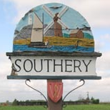
SOUTHERY PARISH COUNCIL
The Annual Parish meeting will be held on Monday 14th May 2018 at 7.00pm in Southery village hall followed by the Annual Parish Council meeting
Public and press are welcome to attend
Agenda

1. Record attendance and receive apologies
2. Minutes of last meeting and matters arising
2. Parish Council Chairman’s Report
3. Reports from Community Organisations, if any
4. Pavilion
3. Public comments and discussion
Opportunity for parishioners to raise any issues of concern or future ideas/projects

.
Helen Richardson
Parish Clerk and RFO
07795006811
parishclerk1@hotmail.co.uk

